Creasey Park Community Football Centre
Advertisement Packages
About us
Creasey Park Community Football Centre is a premium football and local community facility Creasey Park is home to local football clubs Dunstable Town FC and AFC Dunstable and Dunstable Road Runners. The site comprises main stadium football pitch, full size 3G artificial turf pitch, 8 grass pitches, clubhouse with licensed bar and catering facilities, 6 changing rooms and a BMX track.

Why advertise here:

- We can supply and install the advertisement
- We have a variety of customers of all ages
- We are open 7 days a week
- We are local in the community
- On local community events thousands of people can be present.

The main pitch host on average 120 matches per season.
Youth pitches are home to over 40 youth and adult teams.
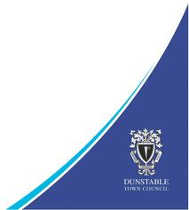
Artificial turf pitch with up to 1000 people training or spectating per week, during the football season.
The centre clubhouse is regularly hired out for evening function, corporate events as well as weekly parent toddler group. Annual firework display attracting up to 15,000 people. Summer football festivals with up to 3,500 people visiting and 150 member strong road runners group.
Advertisement Board Sizes

Main Pitch/ AstroTurf/ Car Park Youth Pitches
2.45m x 1m 1.65m x70cm
2
1

Door Entrance Panels Indoor Centre Frames
79cm x 68cm A3 A4
4
3
4
Please enquire about a full facility sponsorship package
Prices (per item)
Per year Per 6 months
1 £350.00 £200.00
1* £500.00 £350.00
2 £250.00 £150.00
2* £360.00 £260.00
3 £125.00 £75.00
4 – A3 £40.00 £25.00
4 – A4 £25.00 £17.00
*Includes cost to produce board, no design
All prices excluding VAT
All prices excluding VAT

2.45 x 1m £
1.65m x 70cm £
79cm x 68cm £
Indoor Frames A3 / A4 £

Site Locations
Main Pitch Youth Pitches Car Park
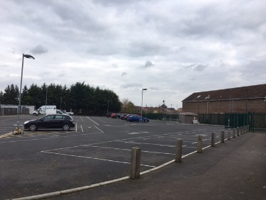
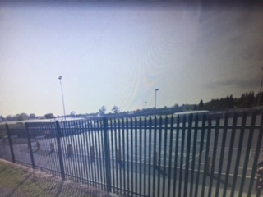
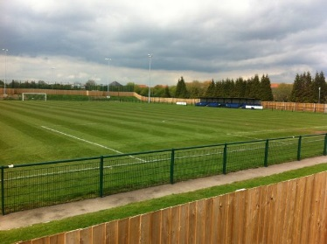
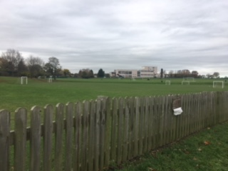

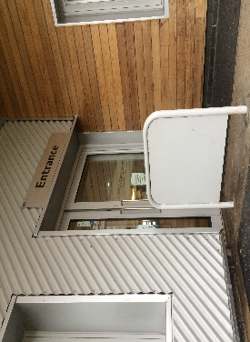
3G Artificial Pitch Clubhouse Door Panels
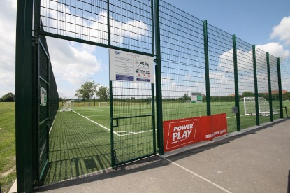
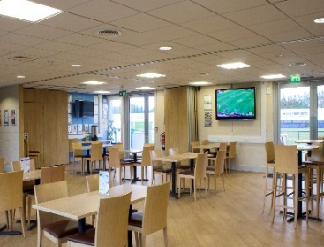

For more information please contact:
Ph.01582 891433
Nichola.Hart@dunstable.gov.uk
https://www.facebook.com/CreaseyPark/
https://twitter.com/CreaseyPark

